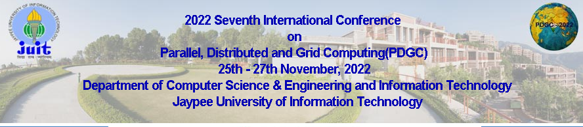

The Special Session organizer must email (pdgc2022@gmail.com) to Conference Committee, the following Special Session Details-

- Title of the Special Session:
- Significance of the topic:
- Special Session organizer’s name, affiliation, and Email:
- A short CV including Invited paper/presentation Details (optional):
- List of reviewers (at least 5)
Full Name of the reviewer | Affiliation of the reviewer | Email address of the reviewer

